MAXIMUM SUBMATRIX SUM PROBLEM
Date: 2023-10-20
Declaration：
I hereby declare that all the work done in this project titled “MAXIMUM SUBMATRIX SUM PROBLEM” is of my independent effort.

Chapter1: Introduction
Problem Description: The maximum submatrix search problem refers to finding a submatrix within a given two-dimensional matrix such that the sum of all elements in the submatrix is maximum. This is a classic algorithmic problem in computer science, and there are various methods and algorithms available to solve it. The project improves the algorithm for the maximum subsequence sum of a one-dimensional array, transforming the problem of the two-dimensional matrix into a one-dimensional problem for resolution.

Chapter2: Algorithm Specification
Algorithm 1: This algorithm involves exhaustive searching of all possible submatrices to find the one with the maximum sum. It uses nested loops for iteration and checks the sum of each submatrix. The submatrix with the highest sum is considered the maximum submatrix.
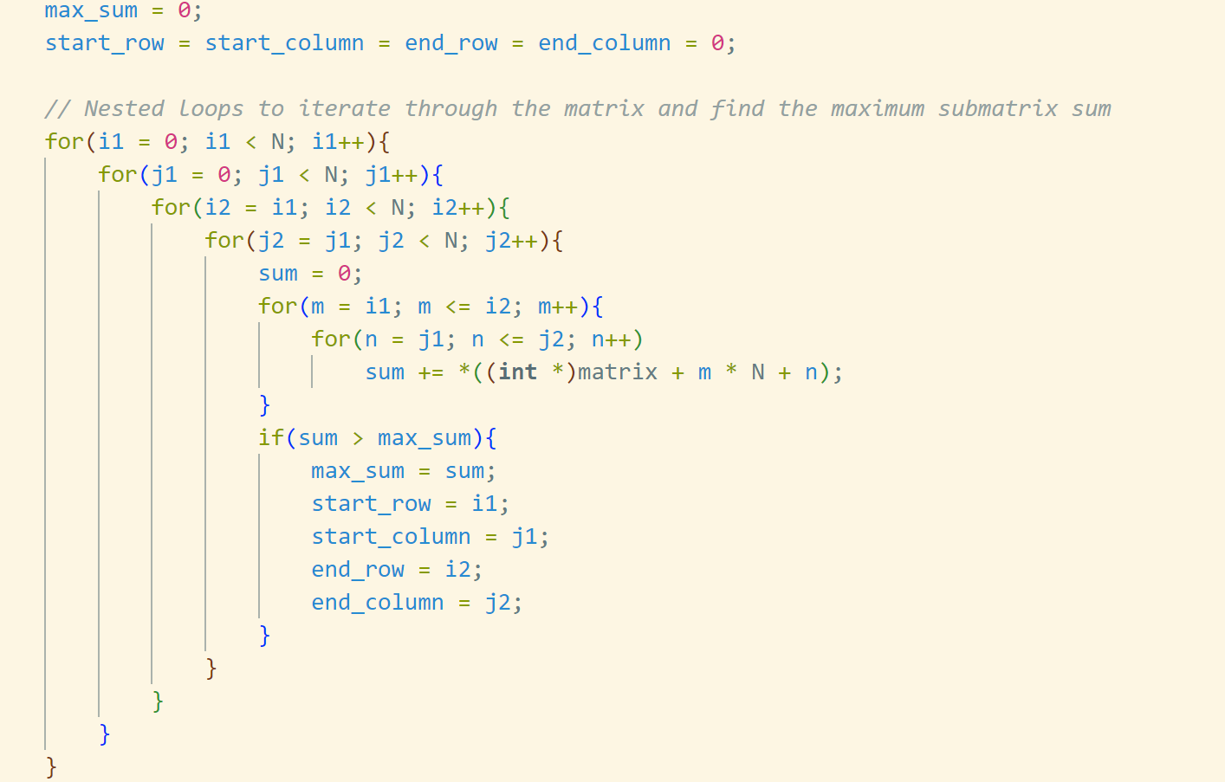

Algorithm 2: Unlike the first algorithm, this approach employs a more optimized technique. It calculates the sum of submatrices using cumulative column sums and sliding windows. By maintaining the sums of columns and iterating through the rows, it efficiently finds the maximum submatrix.
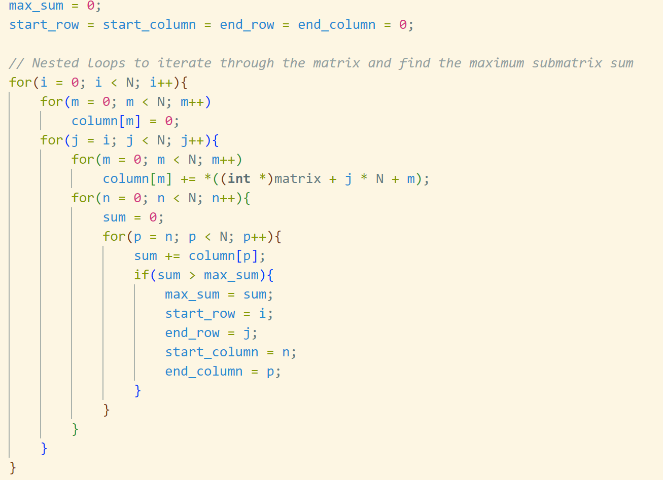
Algorithm 3: This algorithm further improves the efficiency by employing the Kadane's algorithm for finding the maximum subarray sum in a one-dimensional array. It dynamically adjusts the starting and ending points of the submatrix to ensure that the maximum sum is achieved.
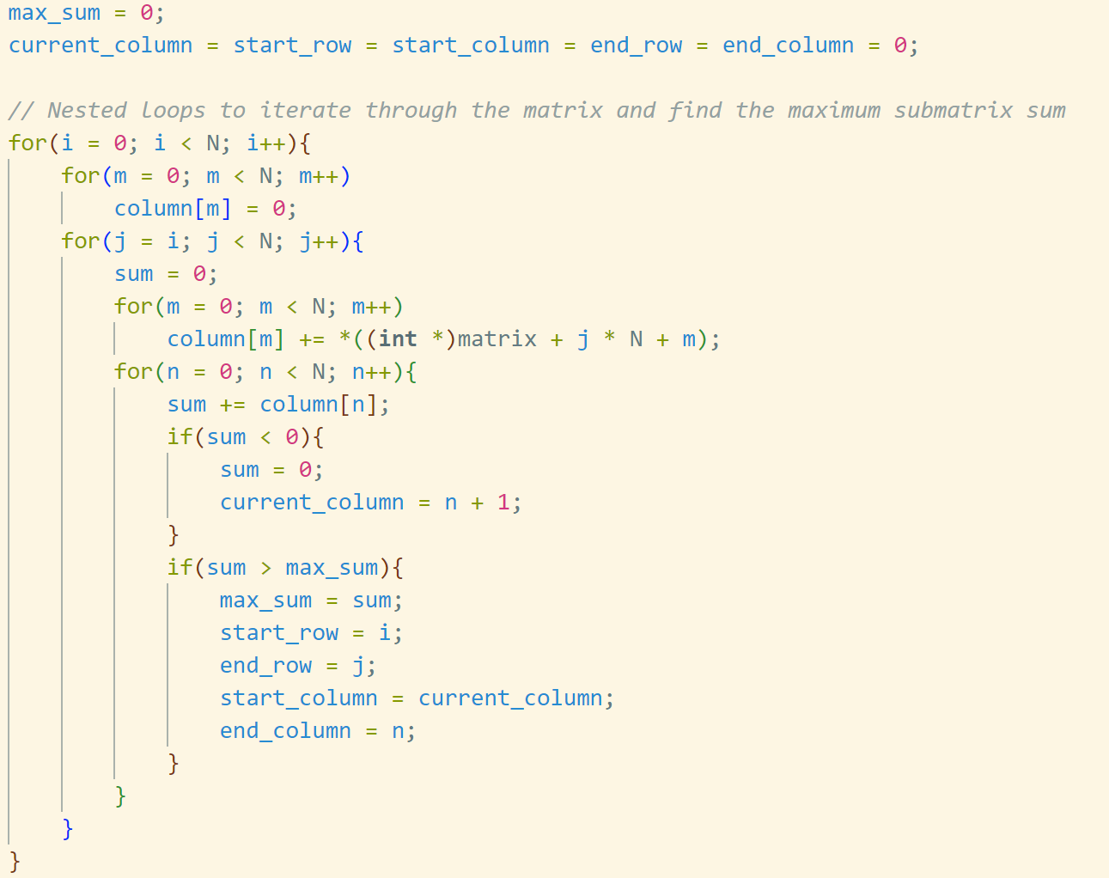

These algorithms use a two-dimensional matrix to represent the input data. The main data structure involves the matrix itself, which is a 2D array in C. The program utilizes this structure to perform various operations on the elements within the matrix, such as calculating sums and accessing specific submatrices.
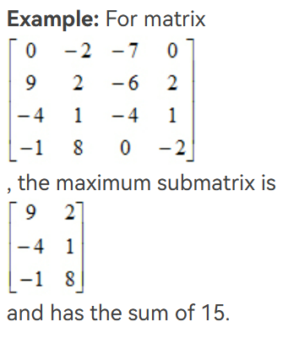

Chapter3: Testing Results
First, let's test the example provided by PTA：

And here is the result provided by project1.c:
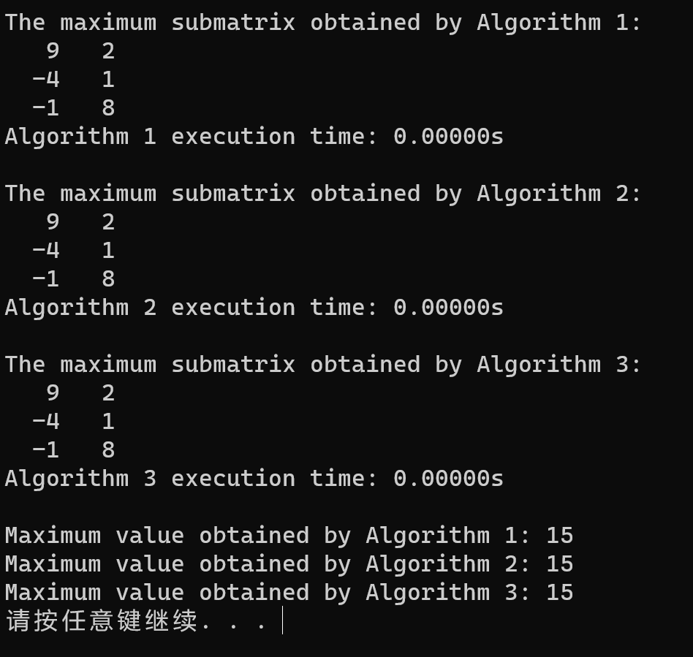-

The following is the finding of the maximum sub-matrix of a randomly generated 5*5 matrix. You can verify that the result is correct.

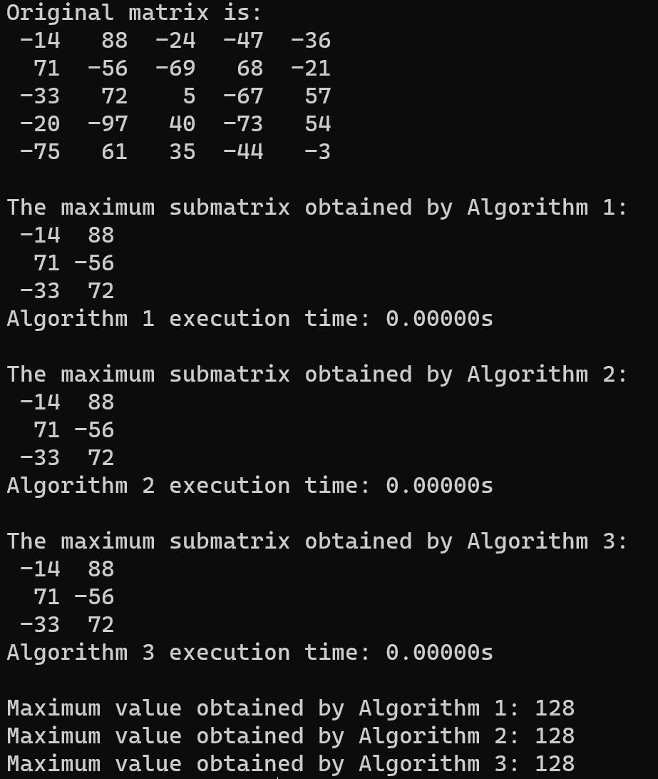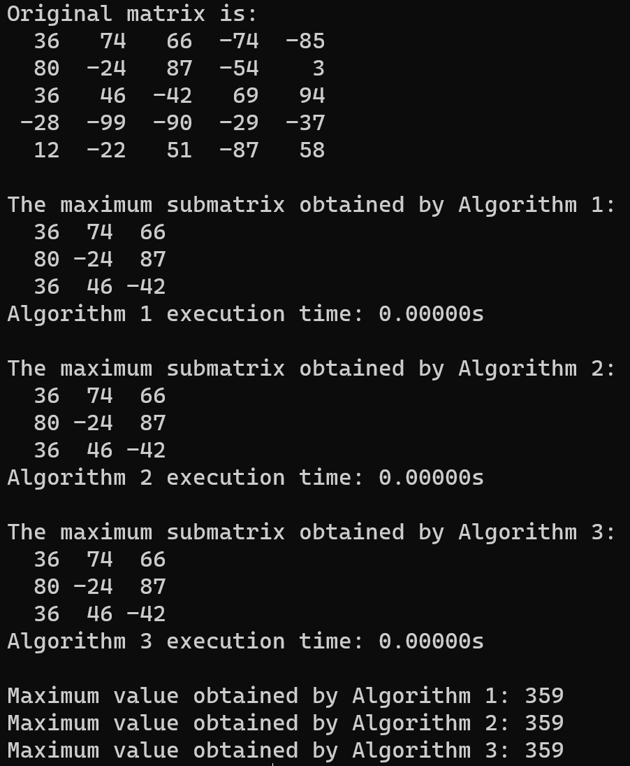
Chapter 4: Analysis and Comments
According to the provided source code, the time complexity of the three algorithms can be calculated as O(N^6), O(N^4), and O(N^3), respectively. (The function runs so quickly when N is not large enough, so we repeat the function calls for K times to obtain a total run time, and then divide the total time by K to obtain a more accurate duration for a single run of the function.) Next, we will verify this conclusion through testing. The following are the results:
 | N | 5 | 10 | 30 | 50 | 80 | 100
O(N⁶) | Iterations(K) | 10000 | 10000 | 100 | 10 | 1 | 1
O(N⁶) | Ticks | 71 | 1371 | 6593 | 29590 | 52312 | 295480
O(N⁶) | Total Time(sec) | 0.071 | 1.371 | 6.593 | 29.59 | 52.312 | 259.48
O(N⁶) | Duration(sec) | 7.1*10⁻⁶ | 1.371*10⁻⁵ | 0.06593 | 2.959 | 52.312 | 259.48
O(N⁴) | Iterations(K) | 100000 | 100000 | 1000 | 100 | 100 | 100
O(N⁴) | Ticks | 1430 | 1030 | 718 | 1668 | 9642 | 22405
O(N⁴) | Total Time(sec) | 0.143 | 1.03 | 0.718 | 1.668 | 9.642 | 22.405
O(N⁴) | Duration(sec) | 1.43*10⁻⁶ | 1.03*10⁻⁵ | 7.18*10⁻⁴ | 0.01668 | 0.09642 | 0.22405
O(N³) | Iterations(K) | 100000 | 100000 | 10000 | 1000 | 1000 | 1000
O(N³) | Ticks | 62 | 354 | 1456 | 1492 | 5928 | 11244
O(N³) | Total Time(sec) | 0.062 | 0.354 | 1.456 | 1.492 | 5.928 | 11.244
O(N³) | Duration(sec) | 6.2*10⁻⁷ | 3.54*10⁻⁶ | 1.456*10⁻⁴ | 1.492*10⁻³ | 5.928*10⁻³ | 0.011244

We can observe that with the change of N, the growth rate of the algorithm's running time is essentially consistent with its time complexity, and when N is large, the running speeds of the three algorithms show significant differences.

The following is an analysis of the space complexity of the three algorithms:
- The max_matrix_sum1 algorithm, besides storing the input N * N matrix, primarily utilizes several integer variables to track the position and value of the maximum sub-matrix, resulting in a space complexity of O (1).
- The max_matrix_sum2 algorithm, apart from storing the input N * N matrix, also employs a one-dimensional array, 'column,' of size N to record the sum of elements in a particular column. Consequently, its space complexity is O (N).
- In the max_matrix_sum3 algorithm, in addition to storing the input N * N matrix, it utilizes a one-dimensional array, 'column,' of size N, along with several integer variables to track the position and value of the maximum sub-matrix. Hence, its space complexity is O(N).

Summarize these three algorithms:
The max_matrix_sum1 algorithm is a naive brute-force search method with a relatively high time complexity, requiring nested loops to iterate through all possible submatrices. Although simple to implement, it is less efficient for large-scale matrices. Compared to the first algorithm, the max_matrix_sum2 algorithm improves efficiency by maintaining cumulative column sums and utilizing sliding windows to avoid unnecessary redundant computations. Its space complexity is higher due to the need for additional storage of column cumulative sums. The max_matrix_sum3 algorithm is an optimized refinement of the second algorithm, incorporating the Kadane's algorithm to find the maximum subarray sum in a one-dimensional array. By dynamically adjusting the starting and ending points of the submatrix, it further enhances efficiency. Compared to the previous two algorithms, it exhibits superior performance on large-scale matrices.

Overall, the third algorithm is the optimal choice, offering higher efficiency and lower time complexity. For algorithms with more optimal space and time complexities, due to my limited expertise, I currently do not have any in mind.

